Chapter 17
Making Complex Decisions
In which we examine methods for deciding what to do today, given that we may face another decision tomorrow.
In this chapter, we address the computational issues involved in making decisions in a stochastic environment. Whereas Chapter 16 was concerned with one-shot or episodic decision problems, in which the utility of each action’s outcome was well known, we are concerned here with sequential decision problems, in which the agent’s utility depends on a sequence of decisions. Sequential decision problems incorporate utilities, uncertainty, and sensing, and include search and planning problems as special cases. Section 17.1 explains how sequential decision problems are defined, and Section 17.2 describes methods for solving them to produce behaviors that are appropriate for a stochastic environment. Section 17.3 covers multi-armed bandit problems, a specific and fascinating class of sequential decision problems that arise in many contexts. Section 17.4 explores decision problems in partially observable environments and Section 17.5 describes how to solve them.
17.1 Sequential Decision Problems
Suppose that an agent is situated in the 4 × 3 environment shown in Figure 17.1(a). Beginning in the start state, it must choose an action at each time step. The interaction with the environment terminates when the agent reaches one of the goal states, marked +1 or −1. Just as for search problems, the actions available to the agent in each state are given by ACTIONS(s), sometimes abbreviated to A(s); in the 4 × 3 environment, the actions in every state are Up, Down, Left, and Right. We assume for now that the environment is fully observable, so that the agent always knows where it is.
If the environment were deterministic, a solution would be easy: [Up, Up, Right, Right, Right]. Unfortunately, the environment won’t always go along with this solution, because the actions are unreliable. The particular model of stochastic motion that we adopt is illustrated in Figure 17.1(b). Each action achieves the intended effect with probability 0.8, but the rest of the time, the action moves the agent at right angles to the intended direction. Furthermore, if the agent bumps into a wall, it stays in the same square. For example, from the start square (1,1), the action Up moves the agent to (1,2) with probability 0.8, but with probability 0.1, it moves right to (2,1), and with probability 0.1, it moves left, bumps into the wall, and stays in (1,1). In such an environment, the sequence [Up, Up, Right, Right, Right] goes up around the barrier and reaches the goal state at (4,3) with probability 0.8⁵ = 0.32768. There is also a small chance of accidentally reaching the goal by going the other way around with probability 0.1⁴ × 0.8, for a grand total of 0.32776. (See also Exercise 17.MDPX.)
As in Chapter 3, the transition model (or just “model,” when the meaning is clear) describes the outcome of each action in each state. Here, the outcome is stochastic, so we write P(s′ | s, a) for the probability of reaching state s′ if action a is done in state s. (Some authors write T(s, a, s′) for the transition model.) We will assume that transitions are Markovian: the probability of reaching s′ from s depends only on s and not on the history of earlier states.
To complete the definition of the task environment, we must specify the utility function for the agent. Because the decision problem is sequential, the utility function will depend on a sequence of states and actions—an environment history—rather than on a single state. Later in this section, we investigate the nature of utility functions on histories; for now, we simply stipulate that for every transition from s to s′ via action a, the agent receives a reward R(s, a, s′). The rewards may be positive or negative, but they are bounded by ±Rₘₐₓ.
For our particular example, the reward is −0.04 for all transitions except those entering terminal states (which have rewards +1 and −1). The utility of an environment history is just (for now) the sum of the rewards received. For example, if the agent reaches the +1 state after 10 steps, its total utility will be
(9 × −0.04) + 1 = 0.64.
The negative reward of −0.04 gives the agent an incentive to reach (4,3) quickly, so our environment is a stochastic generalization of the search problems of Chapter 3. Another way of saying this is that the agent does not enjoy living in this environment and so it wants to leave as soon as possible.
To sum up: a sequential decision problem for a fully observable, stochastic environment with a Markovian transition model and additive rewards is called a Markov decision process, or MDP, and consists of a set of states (with an initial state s₀); a set ACTIONS(s) of actions in each state; a transition model P(s′ | s, a); and a reward function R(s, a, s′). Methods for solving MDPs usually involve dynamic programming: simplifying a problem by recursively breaking it into smaller pieces and remembering the optimal solutions to the pieces.
The next question is, what does a solution to the problem look like? No fixed action sequence can solve the problem, because the agent might end up in a state other than the goal. Therefore, a solution must specify what the agent should do for any state that the agent might reach. A solution of this kind is called a policy. It is traditional to denote a policy by π, and π(s) is the action recommended by the policy π for state s. No matter what the outcome of the action, the resulting state will be in the policy, and the agent will know what to do next.
Each time a given policy is executed starting from the initial state, the stochastic nature of the environment may lead to a different environment history. The quality of a policy is therefore measured by the expected utility of the possible environment histories generated by that policy. An optimal policy is a policy that yields the highest expected utility. We use π* to denote an optimal policy. Given π*, the agent decides what to do by consulting its current percept, which tells it the current state s, and then executing the action π*(s). A policy represents the agent function explicitly and is therefore a description of a simple reflex agent, computed from the information used for a utility-based agent.
The optimal policies for the world of Figure 17.1 are shown in Figure 17.2(a). There are two policies because the agent is exactly indifferent between going left and going up from (3,1): going left is safer but longer, while going up is quicker but risks falling into (4,2) by accident. In general there will often be multiple optimal policies.

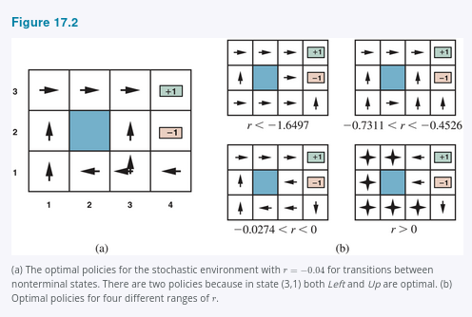
The balance of risk and reward changes depending on the value of
r = R(s, a, s′) for transitions between nonterminal states. The policies shown in Figure 17.2(a) are optimal for −0.0850 < r < −0.0273. Figure 17.2(b) shows optimal policies for four ranges of r. When r < −1.6497, life is so painful that the agent heads straight for the nearest exit, even if the exit is worth −1. When −0.7311 < r < −0.4526, life is quite unpleasant; the agent takes the shortest route to the +1 state from (2,1), (3,1), and (3,2), but from (4,1) the cost of reaching +1 is so high that the agent prefers to dive straight into −1. When life is only slightly dreary (−0.0274 < r < 0), the optimal policy takes no risks at all. In (4,1) and (3,2), the agent heads directly away from the −1 state so that it cannot fall in by accident, even though this means banging its head against the wall quite a few times. Finally, if r > 0, then life is positively enjoyable and the agent avoids both exits. As long as the actions in (4,1), (3,2), and (3,3) are as shown, every policy is optimal, and the agent obtains infinite total reward because it never enters a terminal state. It turns out that there are nine optimal policies in all for various ranges of r; Exercise 17.THRC asks you to find them.
The introduction of uncertainty brings MDPs closer to the real world than deterministic search problems. For this reason, MDPs have been studied in several fields, including AI, operations research, economics, and control theory. Dozens of solution algorithms have been proposed, several of which we discuss in Section 17.2. First, however, we spell out in more detail the definitions of utilities, optimal policies, and models for MDPs.
17.1.1 Utilities over time
In the MDP example in Figure 17.1, the performance of the agent was measured by a sum of rewards for the transitions experienced. This choice of performance measure is not arbitrary, but it is not the only possibility for the utility function on environment histories, which we write as
Uₕ([s₀, a₀, s₁, a₁, …, sₙ]).
The first question to answer is whether there is a finite horizon or an infinite horizon for decision making. A finite horizon means that there is a fixed time N after which nothing matters—the game is over, so to speak. Thus,
Uₕ([s₀, a₀, s₁, a₁, …, sₙ₊ₖ]) = Uₕ([s₀, a₀, s₁, a₁, …, sₙ])
for all k > 0. For example, suppose an agent starts at (3,1) in the 4 × 3 world of Figure 17.1, and suppose that N = 3. Then, to have any chance of reaching the +1 state, the agent must head directly for it, and the optimal action is to go Up. On the other hand, if N = 100, then there is plenty of time to take the safe route by going Left. So, with a finite horizon, an optimal action in a given state may depend on how much time is left. A policy that depends on the time is called nonstationary.
With no fixed time limit, on the other hand, there is no reason to behave differently in the same state at different times. Hence, an optimal action depends only on the current state, and the optimal policy is stationary. Policies for the infinite-horizon case are therefore simpler than those for the finite-horizon case, and we deal mainly with the infinite-horizon case in this chapter. (We will see later that for partially observable environments, the infinite-horizon case is not so simple.) Note that “infinite horizon” does not necessarily mean that all state sequences are infinite; it just means that there is no fixed deadline. There can be finite state sequences in an infinite-horizon MDP that contains a terminal state.
The next question we must decide is how to calculate the utility of state sequences. Throughout this chapter, we will use additive discounted rewards: the utility of a history is
Uₕ([s₀, a₀, s₁, a₁, s₂, …]) = R(s₀, a₀, s₁) + γR(s₁, a₁, s₂) + γ²R(s₂, a₂, s₃) + ⋯,
where the discount factor γ is a number between 0 and 1. The discount factor describes the preference of an agent for current rewards over future rewards. When γ is close to 0, rewards in the distant future are viewed as insignificant. When γ is close to 1, an agent is more willing to wait for long-term rewards. When γ is exactly 1, discounted rewards reduce to the special case of purely additive rewards. Notice that additivity was used implicitly in our use of path cost functions in heuristic search algorithms (Chapter 3).
There are several reasons why additive discounted rewards make sense. One is empirical: both humans and animals appear to value near-term rewards more highly than rewards in the distant future. Another is economic: if the rewards are monetary, then it really is better to get them sooner rather than later because early rewards can be invested and produce returns while you’re waiting for the later rewards. In this context, a discount factor of γ is equivalent to an interest rate of (1/γ) − 1. For example, a discount factor of γ = 0.9 is equivalent to an interest rate of 11.1%.
A third reason is uncertainty about the true rewards: they may never arrive for all sorts of reasons that are not taken into account in the transition model. Under certain assumptions, a discount factor of γ is equivalent to adding a probability 1 − γ of accidental termination at every time step, independent of the action taken.
A fourth justification arises from a natural property of preferences over histories. In the terminology of multiattribute utility theory (see Section 16.4), each transition sₜ → sₜ₊₁ can be viewed as an attribute of the history
[s₀, a₀, s₁, a₁, …].
In principle, the utility function could depend in arbitrarily complex ways on these attributes. There is, however, a highly plausible preference-independence assumption that can be made, namely that the agent’s preferences between state sequences are stationary.
Assume two histories [s₀, a₀, s₁, a₁, s₂, …] and [s′₀, a′₀, s′₁, a′₁, s′₂, …] begin with the same transition (i.e., s₀ = s′₀, a₀ = a′₀, and s₁ = s′₁). Then stationarity for preferences means that the two histories should be preference-ordered the same way as the histories [s₁, a₁, s₂, …] and [s′₁, a′₁, s′₂, …]. In English, this means that if you prefer one future to another starting tomorrow, then you should still prefer that future if it were to start today instead. Stationarity is a fairly innocuous-looking assumption, but additive discounting is the only form of utility on histories that satisfies it.

A final justification for discounted rewards is that it conveniently makes some nasty infinities go away. With infinite horizons there is a potential difficulty: if the environment does not contain a terminal state, or if the agent never reaches one, then all environment histories will be infinitely long, and utilities with additive undiscounted rewards will generally be infinite. While we can agree that +∞ is better than −∞, comparing two state sequences with +∞ utility is more difficult. There are three solutions, two of which we have seen already:
- With discounted rewards, the utility of an infinite sequence is finite. In fact, if γ < 1 and rewards are bounded by ±Rₘₐₓ, we have
(17.1)
Uₕ([s₀, a₀, s₁, …]) = ∑ₜ₌₀^∞ γᵗR(sₜ, aₜ, sₜ₊₁) ≤ ∑ₜ₌₀^∞ γᵗRₘₐₓ = Rₘₐₓ / (1 − γ),
using the standard formula for the sum of an infinite geometric series.
- If the environment contains terminal states and if the agent is guaranteed to get to one eventually, then we will never need to compare infinite sequences. A policy that is guaranteed to reach a terminal state is called a proper policy. With proper policies, we can use γ = 1 (i.e., additive undiscounted rewards). The first three policies shown in Figure 17.2(b) are proper, but the fourth is improper. It gains infinite total reward by staying away from the terminal states when the reward for transitions between nonterminal states is positive. The existence of improper policies can cause the standard algorithms for solving MDPs to fail with additive rewards, and so provides a good reason for using discounted rewards.
- Infinite sequences can be compared in terms of the average reward obtained per time step. Suppose that transitions to square (1,1) in the 4 × 3 world have a reward of 0.1 while transitions to other nonterminal states have a reward of 0.01. Then a policy that does its best to stay in (1,1) will have higher average reward than one that stays elsewhere. Average reward is a useful criterion for some problems, but the analysis of average-reward algorithms is complex.
Additive discounted rewards present the fewest difficulties in evaluating histories, so we shall use them henceforth.
17.1.2 Optimal policies and the utilities of states
Having decided that the utility of a given history is the sum of discounted rewards, we can compare policies by comparing the expected utilities obtained when executing them. We assume the agent is in some initial state s and define Sₜ (a random variable) to be the state the agent reaches at time t when executing a particular policy π. (Obviously, S₀ = s, the state the agent is in now.) The probability distribution over state sequences S₁, S₂, … is determined by the initial state s, the policy π, and the transition model for the environment.
The expected utility obtained by executing π starting in s is given by
(17.2)
U^π(s) = E[∑ₜ₌₀^∞ γᵗR(Sₜ, π(Sₜ), Sₜ₊₁)],
where the expectation E is with respect to the probability distribution over state sequences determined by s and π. Now, out of all the policies the agent could choose to execute starting in s, one (or more) will have higher expected utilities than all the others. We’ll use π*ₛ to denote one of these policies:
(17.3)
π*ₛ = argmax₍π₎ U^π(s).
Remember that πₛ is a policy, so it recommends an action for every state; its connection with s in particular is that it’s an optimal policy when s is the starting state. A remarkable consequence of using discounted utilities with infinite horizons is that the optimal policy is independent of the starting state. (Of course, the action sequence won’t be independent; remember that a policy is a function specifying an action for each state.) This fact seems intuitively obvious: if policy πₐ is optimal starting in a and policy πᵦ is optimal starting in b, then, when they reach a third state c, there’s no good reason for them to disagree with each other, or with π𝚌, about what to do next. So we can simply write π* for an optimal policy.
Given this definition, the true utility of a state is just U^π*(s)—that is, the expected sum of discounted rewards if the agent executes an optimal policy. We write this as U(s), matching the notation used in Chapter 16 for the utility of an outcome. Figure 17.3 shows the utilities for the 4 × 3 world. Notice that the utilities are higher for states closer to the +1 exit, because fewer steps are required to reach the exit.

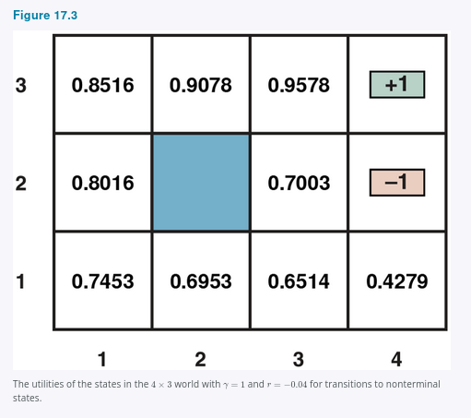
The utility function U(s) allows the agent to select actions by using the principle of maximum expected utility from Chapter 16—that is, choose the action that maximizes the reward for the next step plus the expected discounted utility of the subsequent state:
(17.4)
π*(s) = argmaxₐ∈A(s) ∑ₛ′ P(s′ | s, a)[R(s, a, s′) + γU(s′)].
We have defined the utility of a state, U(s), as the expected sum of discounted rewards from that point onwards. From this, it follows that there is a direct relationship between the utility of a state and the utility of its neighbors: the utility of a state is the expected reward for the next transition plus the discounted utility of the next state, assuming that the agent chooses the optimal action. That is, the utility of a state is given by
(17.5)
U(s) = maxₐ∈A(s) ∑ₛ′ P(s′ | s, a)[R(s, a, s′) + γU(s′)].
This is called the Bellman equation, after Richard Bellman (1957). The utilities of the states—defined by Equation (17.2) as the expected utility of subsequent state sequences—are solutions of the set of Bellman equations. In fact, they are the unique solutions, as we show in Section 17.2.1.
Let us look at one of the Bellman equations for the 4 × 3 world. The expression for U(1,1) is
max {
[0.8(−0.04 + γU(1,2)) + 0.1(−0.04 + γU(2,1)) + 0.1(−0.04 + γU(1,1))],
[0.9(−0.04 + γU(1,1)) + 0.1(−0.04 + γU(1,2))],
[0.9(−0.04 + γU(1,1)) + 0.1(−0.04 + γU(2,1))],
[0.8(−0.04 + γU(2,1)) + 0.1(−0.04 + γU(1,2)) + 0.1(−0.04 + γU(1,1))]
}
where the four expressions correspond to Up, Left, Down and Right moves. When we plug in the numbers from Figure 17.3, with γ = 1, we find that Up is the best action.
Another important quantity is the action-utility function, or Q-function: Q(s, a) is the expected utility of taking a given action in a given state. The Q-function is related to utilities in the obvious way:
(17.6)
U(s) = maxₐ Q(s, a).
Furthermore, the optimal policy can be extracted from the Q-function as follows:
(17.7)
π*(s) = argmaxₐ Q(s, a).
We can also develop a Bellman equation for Q-functions, noting that the expected total reward for taking an action is its immediate reward plus the discounted utility of the outcome state, which in turn can be expressed in terms of the Q-function:
(17.8)
Q(s, a) = ∑ₛ′ P(s′ | s, a)[R(s, a, s′) + γU(s′)]
= ∑ₛ′ P(s′ | s, a)[R(s, a, s′) + γ maxₐ′ Q(s′, a′)].
Solving the Bellman equations for U (or for Q) gives us what we need to find an optimal policy. The Q-function shows up again and again in algorithms for solving MDPs, so we shall use the following definition:
function Q-VALUE(mdp, s, a, U) returns a utility value
return ∑ₛ′ P(s′ | s, a)[R(s, a, s′) + γU(s′)]
17.1.3 Reward scales
Chapter 16 noted that the scale of utilities is arbitrary: an affine transformation leaves the optimal decision unchanged. We can replace U(s) by
U′(s) = mU(s) + b
where m and b are any constants such that m > 0. It is easy to see, from the definition of utilities as discounted sums of rewards, that a similar transformation of rewards will leave the optimal policy unchanged in an MDP:
R′(s, a, s′) = mR(s, a, s′) + b.
It turns out, however, that the additive reward decomposition of utilities leads to significantly more freedom in defining rewards. Let Φ(s) be any function of the state s. Then, according to the shaping theorem, the following transformation leaves the optimal policy unchanged:
(17.9)
R′(s, a, s′) = R(s, a, s′) + γΦ(s′) − Φ(s).
To show that this is true, we need to prove that two MDPs, M and M′, have identical optimal policies as long as they differ only in their reward functions as specified in Equation (17.9). We start from the Bellman equation for Q, the Q-function for MDP M:
Q(s, a) = ∑ₛ′ P(s′ | s, a)[R(s, a, s′) + γ maxₐ′ Q(s′, a′)].
Now let
Q′(s, a) = Q(s, a) − Φ(s)
and plug it into this equation; we get
Q′(s, a) + Φ(s) = ∑ₛ′ P(s′ | s, a)[R(s, a, s′) + γ maxₐ′(Q′(s′, a′) + Φ(s′))],
which then simplifies to
In other words, Q′(s, a) satisfies the Bellman equation for MDP M′. Now we can extract the optimal policy for M′ using Equation (17.7):
π*₍M′₎(s) = argmaxₐ Q′(s, a) = argmaxₐ [Q(s, a) − Φ(s)] = argmaxₐ Q(s, a) = π*₍M₎(s).
The function Φ(s) is often called a potential, by analogy to the electrical potential (voltage) that gives rise to electric fields. The term γΦ(s′) − Φ(s) functions as a gradient of the potential. Thus, if Φ(s) has higher value in states that have higher utility, the addition of γΦ(s′) − Φ(s) to the reward has the effect of leading the agent “uphill” in utility.
At first sight, it may seem rather counterintuitive that we can modify the reward in this way without changing the optimal policy. It helps if we remember that all policies are optimal with a reward function that is zero everywhere. This means, according to the shaping theorem, that all policies are optimal for any potential-based reward of the form
R(s, a, s′) = γΦ(s′) − Φ(s).
Intuitively, this is because with such a reward it doesn’t matter which way the agent goes from A to B. (This is easiest to see when γ = 1: along any path the sum of rewards collapses to Φ(B) − Φ(A), so all paths are equally good.) So adding a potential-based reward to any other reward shouldn’t change the optimal policy.
The flexibility afforded by the shaping theorem means that we can actually help out the agent by making the immediate reward more directly reflect what the agent should do. In fact, if we set Φ(s) = U(s), then the greedy policy π_G with respect to the modified reward R′ is also an optimal policy:
π_G(s) = argmaxₐ ∑ₛ′ P(s′ | s, a)R′(s, a, s′)
= argmaxₐ ∑ₛ′ P(s′ | s, a)[R(s, a, s′) + γΦ(s′) − Φ(s)]
= argmaxₐ ∑ₛ′ P(s′ | s, a)[R(s, a, s′) + γU(s′) − U(s)]
= argmaxₐ ∑ₛ′ P(s′ | s, a)[R(s, a, s′) + γU(s′)]
= π*(s) (by Equation (17.4)).
Of course, in order to set Φ(s) = U(s), we would need to know U(s); so there is no free lunch, but there is still considerable value in defining a reward function that is helpful to the extent possible. This is precisely what animal trainers do when they provide a small treat to the animal for each step in the target sequence.
17.1.4 Representing MDPs
The simplest way to represent P(s′ | s, a) and R(s, a, s′) is with big, three-dimensional tables of size |S|²|A|. This is fine for small problems such as the 4 × 3 world, for which the tables have 11² × 4 = 484 entries each. In some cases, the tables are sparse—most entries are zero because each state s can transition to only a bounded number of states s′—which means the tables are of size O(|S||A|). For larger problems, even sparse tables are far too big.
Just as in Chapter 16, where Bayesian networks were extended with action and utility nodes to create decision networks, we can represent MDPs by extending dynamic Bayesian networks (DBNs, see Chapter 14) with decision, reward, and utility nodes to create dynamic decision networks, or DDNs. DDNs are factored representations in the terminology of Chapter 2; they typically have an exponential complexity advantage over atomic representations and can model quite substantial real-world problems.
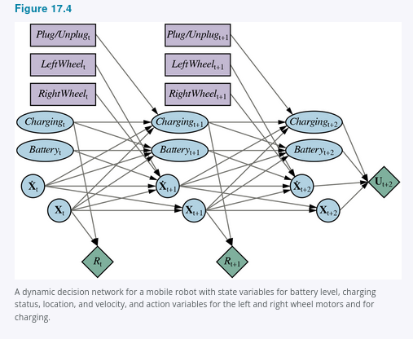
Figure 17.4, which is based on the DBN in Figure 14.13(b), shows some elements of a slightly realistic model for a mobile robot that can charge itself. The state Sₜ is decomposed into four state variables:

• Xₜ consists of the two-dimensional location on a grid plus the orientation;
• Ẋₜ is the rate of change of Xₜ;
• Chargingₜ is true when the robot is plugged in to a power source;
• Batteryₜ is the battery level, which we model as an integer in the range 0, …, 5.
The state space for the MDP is the Cartesian product of the ranges of these four variables. The action is now a set Aₜ of action variables, comprised of Plug/Unplug, which has three values (plug, unplug, and noop); LeftWheel for the power sent to the left wheel; and RightWheel for the power sent to the right wheel. The set of actions for the MDP is the Cartesian product of the ranges of these three variables. Notice that each action variable affects only a subset of the state variables.
The overall transition model is the conditional distribution P(Xₜ₊₁ | Xₜ, Aₜ), which can be computed as a product of conditional probabilities from the DDN. The reward here is a single variable that depends only on the location X (for, say, arriving at a destination) and Charging, as the robot has to pay for electricity used; in this particular model, the reward doesn’t depend on the action or the outcome state.
The network in Figure 17.4 has been projected three steps into the future. Notice that the network includes nodes for the rewards for t, t + 1, and t + 2, but the utility for t + 3. This is because the agent must maximize the (discounted) sum of all future rewards, and U(Xₜ₊₃) represents the reward for all rewards from t + 3 onwards. If a heuristic approximation to U is available, it can be included in the MDP representation in this way and used in lieu of further expansion. This approach is closely related to the use of bounded-depth search and heuristic evaluation functions for games in Chapter 5.
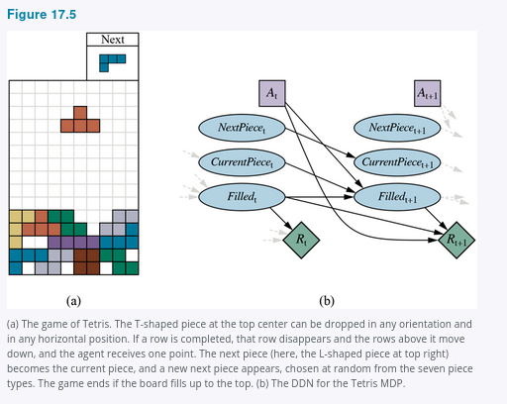
Another interesting and well-studied MDP is the game of Tetris (Figure 17.5(a)). The state variables for the game are the CurrentPiece, the NextPiece, and a bit-vector-valued variable Filled with one bit for each of the 10 × 20 board locations. Thus, the state space has
7 × 7 × 2²⁰⁰ ≈ 10⁶² states.
The DDN for Tetris is shown in Figure 17.5(b). Note that Filledₜ₊₁ is a deterministic function of Filledₜ and Aₜ. It turns out that every policy for Tetris is proper (reaches a terminal state): eventually the board fills despite one’s best efforts to empty it.

